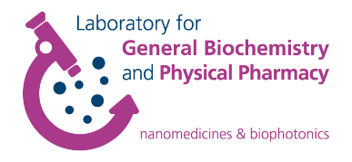

LECTURE INVITATION

*11:00 am* **Tackling inflammatory eye diseases – Connexins, inflammasomes and innovative drug delivery systems**

Prof. Dr. Ilva Rupenthal, University of Auckland, New Zealand

The seminar will take place on **Friday 20th of Octobre** in **Lokaal 0.1 – Rosalin Yalow** at the **Faculty of pharmaceutical sciences,** Ottergemsesteenweg 460, 9000 Ghent, Belgium.

**Contact:** Prof. Katrien Remaut ([Katrien.Remaut@UGent.be](mailto:Katrien.Remaut@UGent.be))

**Tackling inflammatory eye diseases – Connexins, inflammasomes and innovative drug delivery systems**

Dr Ilva Rupenthal is an Associate Professor in the Department of Ophthalmology, University of Auckland, New Zealand, and the Director of the Buchanan Ocular Therapeutics Unit (www.botu.nz), which aims to translate ocular therapeutic related scientific research into the clinical setting. In her presentation, Ilva will give an overview of the research performed by the BOTU team focussing on ocular delivery of small and large molecular weight connexin hemichannel blockers. The talk will highlight various drug delivery approaches as well as preclinical models used to translate these novel ocular therapeutics from bench to bedside.